|  |  |
| --- | --- |
| 0.1 | **Lists of figures or tables** |

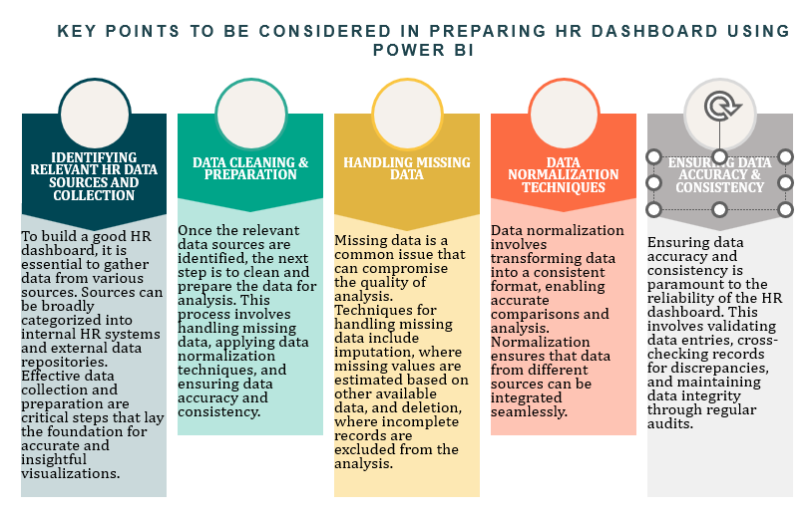

**Figure 1:** Points to be considered in preparing the HR Dashboard using Power BI

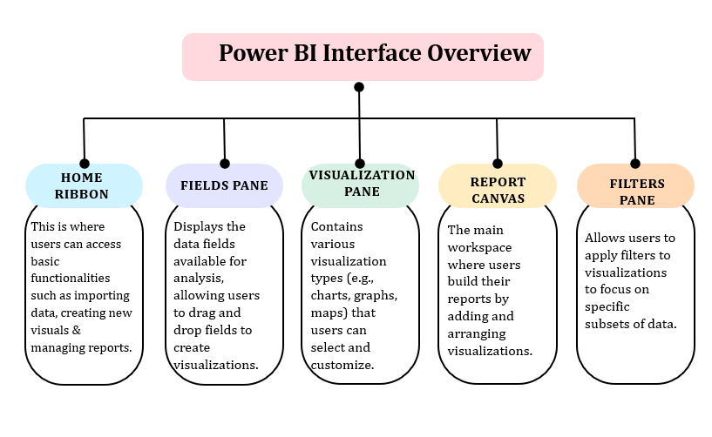

**Figure 2:** Power BI Interface overview

**Table 1:** Elements in dashboard creation and visualisation methods

|  |  |  |
| --- | --- | --- |
| Key Aspect | Description | Visualisation Methods |
| Age Distribution | Helps organisations understand the age composition of their workforce, aiding in workforce planning, succession planning, and targeted training programs.[Dessler (2019)] | Histograms, Bar Charts |
| Gender Ratio | Provides insights into the gender composition of the workforce, important for assessing gender diversity and equity within the organisation. [Hunt, Layton, & Prince (2015)] | Pie Charts, Bar Charts |
| Departmental Breakdown | Shows the distribution of employees across different departments, aiding in understanding organisational structure and identifying departments needing additional resources. [Ulrich, Younger, & Brockbank (2012)] | Bar Charts, Stacked Bar Charts |
| Charts | Essential for visualising demographic metrics. Age distribution can be displayed using histograms or bar charts, gender ratio using pie or bar charts, and departmental breakdown using bar or stacked bar charts. | Histograms, Bar Charts, Pie Charts, Stacked Bar Charts |
| Tables | Useful for presenting detailed demographic data in a structured format, such as employee names, ages, genders, and departments, complementing graphical representations for granular analysis. | Customisable Tables |
| Slicers | Interactive filters that enable users to dynamically adjust the data displayed in visuals, enhancing dashboard interactivity and usability. [Chapple (2018)] | Slicers for filtering data by department or other criteria |
| Filters | Allow users to refine dashboard data based on specific criteria, with visual, page, and report-level filters providing flexible data exploration options. [Ferrari & Russo (2016)] | Visual-Level Filters, Page-Level Filters, Report-Level Filters |
| Drill-Downs | Provide a hierarchical view of data, allowing users to explore detailed information by navigating through different levels of granularity, enhancing dashboard interactivity and facilitating in-depth analysis. [Randall (2018)] | Drill-Downs within charts to explore detailed metrics by department or other categories |